Circulatory System

Composition of Blood
Blood is composed of a watery plasma and suspended solids such as blood cells. The blood transports nutrients such as amino acids, glucose, vitamins, minerals and lipids to tissues that need them. Red blood corpuscles carry oxygen, wastes such as urea and some CO₂ while some CO₂ is also carried in the plasma. White blood cells such as monocytes and lymphocytes protect against infections. Platelets help in blood clotting; Hormones and antibodies are carried to all parts of the body in the blood.

Blood cell types
Red Blood Cells | White Blood Cells | Platelets
Biconcave disc-shaped cells made in the bone marrow. | Made by the bone marrow and lymphatic tissue. | These are tiny fragments of large bone marrow cells.
Do not have a nucleus. | Possess a nucleus. | Nucleus is not present.
Rich in haemoglobin to carry oxygen | Defending the body against pathogens. | Carry blood clotting chemicals.

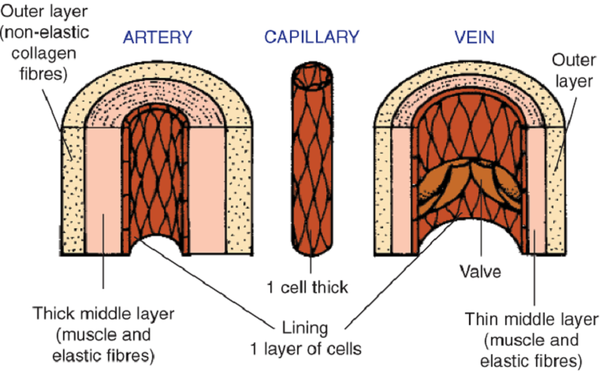Blood Vessels
There are 3 main types of blood vessels – arteries, veins and capillaries. The wall of the artery is thicker compared to a vein and has a narrower lumen. Arteries do not have-valves, veins do. Blood flows away from the heart in arteries and back to the heart in veins. Blood pressure in arteries is higher. Capillaries are tiny blood vessels that link arteries to veins. It is at the capillaries that food and oxygen leave the blood and enter body cells. Capillary walls are one cell thick to allow materials to pass in and out.

Blood Grouping Systems
ABO Blood Grouping System | Rhesus Blood Grouping System
The blood group depends on the presence or absence of proteins called antigens on the cell surface.  Group A has antigen A only. Group B has antigen B only. Group AB has antigen A and antigen B. Group O has neither antigen. | The group depends on the presence or absence of a protein called the Rhesus-antigen.  Rh-positive blood has the Rhesus antigen.  Rh-negative does not have the Rhesus-antigen.

Double Circuit
In the pulmonary circuit deoxygenated blood flows from the heart to the lungs, oxygen is taken in and carbon dioxide is excreted. Oxygenated blood flows from the lungs back to the heart. In the systemic circuit oxygenated blood flows from the heart to the organ systems of the body, oxygen is delivered and carbon dioxide is taken on, deoxygenated blood flow from the organs systems back to the heart.

The Heart
The heart is located in the thoracic cavity between the lungs protected by the rib cage. The right side collects deoxygenated blood from all parts and pumps it to the lungs for oxygenation and excretion of CO₂. The left side collects oxygenated blood from the lungs and pumps it to all parts of the body. The wall of the left ventricle is about three times thicker than that of the right ventricle, as the left ventricle needs to pump blood all around the body.

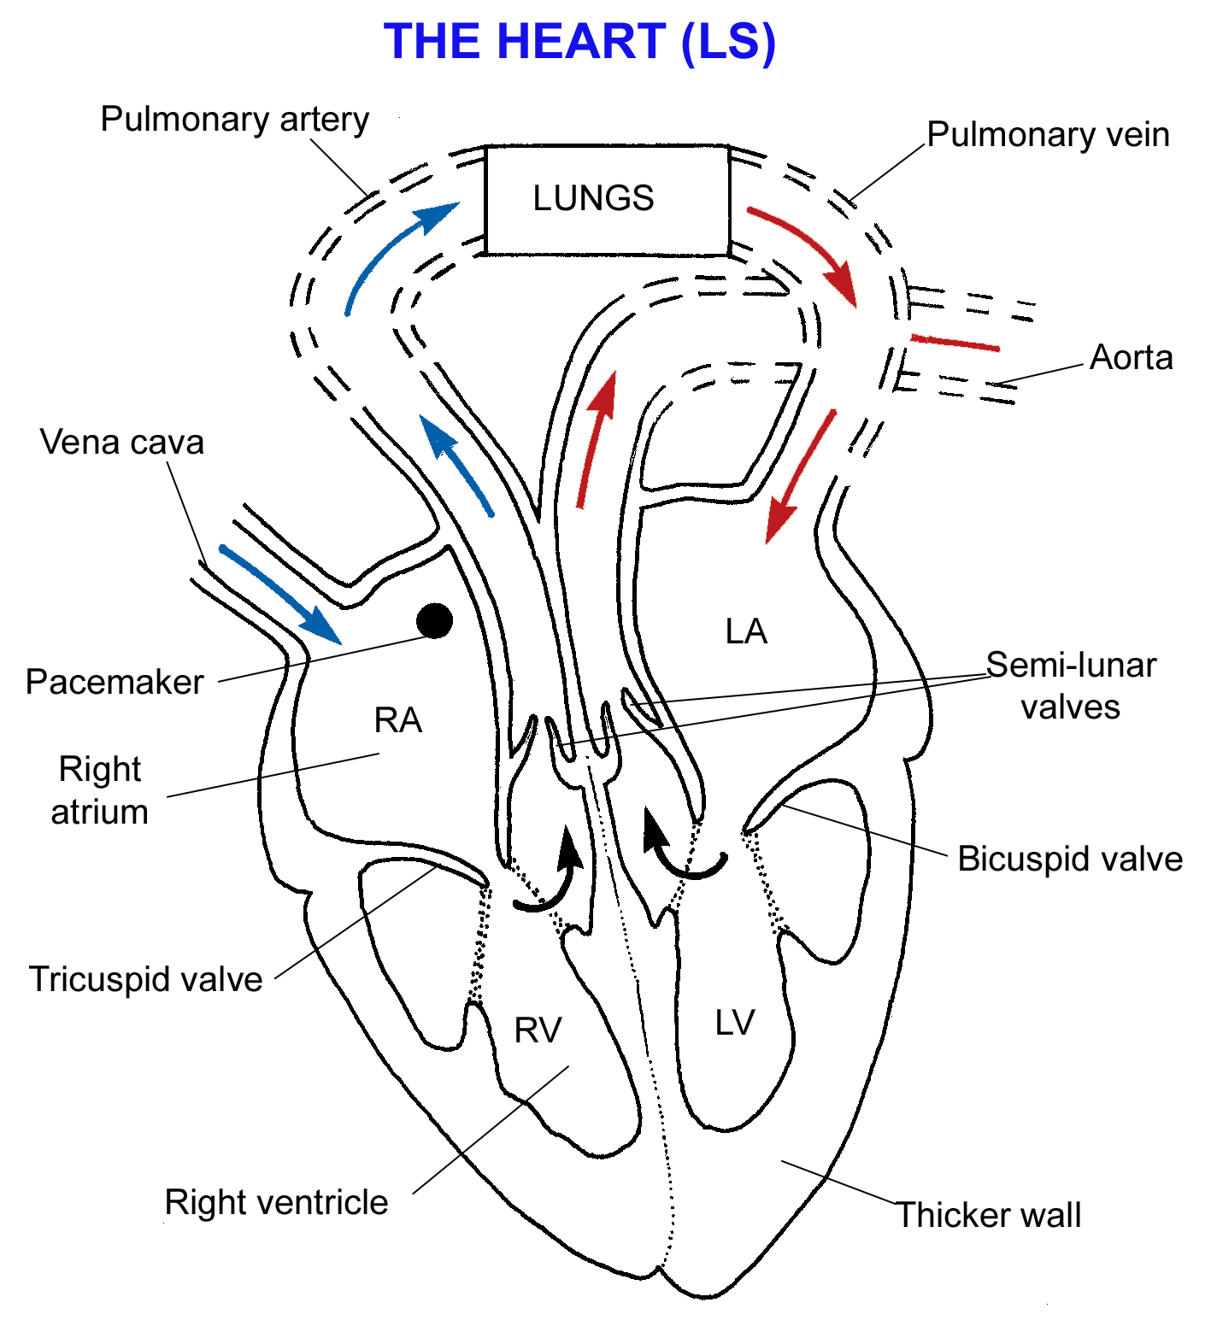
Heart action
Cardiac muscle is an involuntary, strong muscle that does not fatigue. A diastole is a relaxation of the cardiac muscle. Systole is contracting heart muscle. The pacemaker in the right atrium regulates contraction of the heart be producing regular nerve impulses.
Blood enters both atria at the same time and flows down through the bicuspid and tricuspid valves to fill both ventricles. The atria continue to fill with blood. The pacemaker (sino-atrial node) in the right atrium generates a nerve impulse causing the atria to contract, squeezing the blood into the ventricles. The atria relax and the ventricles contract and force the blood through the openings of pulmonary artery and aorta. The cuspid valves close (lub sound) preventing blood returning to the atria. The semilunar valves are pushed open as the blood enters the arteries. When the ventricles relax backflow of blood closes of the semilunar valves (dub sound) preventing blood flowing back into the ventricles.
Two coronary arteries arise from the aorta and give the heart its own blood supply

Factors affecting heart rate
The average human heart beats at 72 bpm. Exercise, increased body temperature, stress, mental excitement and infection all increase heart rate. Increased physical fitness, sleep certain drugs and mental relaxation decrease the heart rate
Effect of Smoking | Effect of poor Diet | Effect of no Exercise
Hardening of the arteries. | Anaemia: lack of iron. | Faster resting heart rate
Raised blood pressure. | High Blood Pressure: excessive salt. | Constricted arteries
Increased risk of stroke. | Low Blood Pressure: lack of protein. | More risk of heart disease.
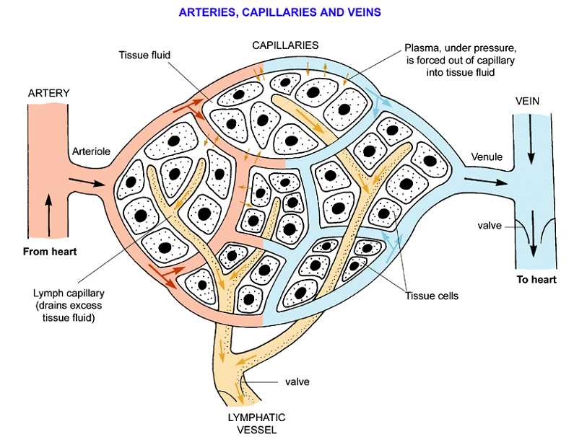
The Lymphatic System
The blood pressure in capillaries forces some of the plasma out through the wall. The escaped fluid is called tissue fluid similar in composition to plasma. At the venule end most of the escaped tissue fluid is drawn back into the blood. The lymphatic system collects the remaining tissue fluid and returns it to the blood via the thoracic duct and subclavian vein. Lymph also collects the absorbed lipids from the small intestine. Lymph vessels have are valves. Distributed along the lymph vessels are lymph nodes that filter the lymph and produce lymphocytes that protect against pathogens.

